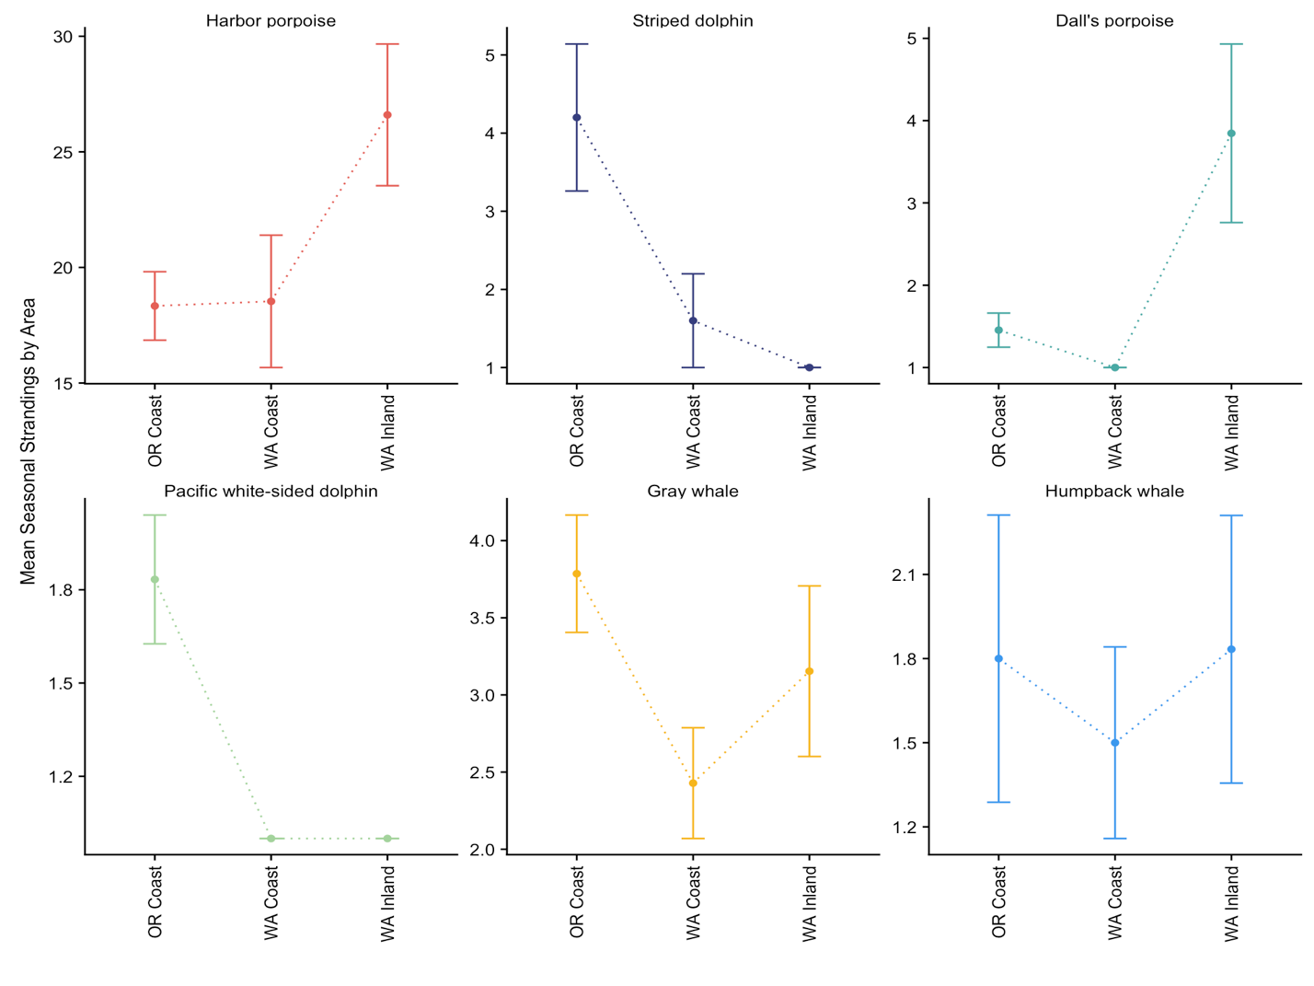

|  |  |  |  |  |  |  |  |
| --- | --- | --- | --- | --- | --- | --- | --- |
| Species | Variable | Estimate | Std Error | z | P(>|z|) | AIC | χ2 |
| **Harbor porpoise** | Intercept | 5.19/179.47 | 0.42 | 12.34 | <0.001 | 660.25 | 0.498 |
| **SST 44° (2 mo lag)** | **-0.31/0.73** | **0.04** | **-8.50** | **<0.001** |
| **MEI (1 mo lag)** | **-0.14/0.87** | **0.08** | **-1.68** | **0.092** |
| N. CBA | -0.05/0.95 | 0.14 | -0.35 | 0.73 |
| **Market squid** | **0.95/2.58** | **0.31** | **3.03** | **0.002** |
| **Sardine** | **-0.53/0.59** | **0.176** | **-3.01** | **0.003** |
| **Harbor porpoise**  *(without fish)* | Intercept | 5.17/175.91 | 0.44 | 11.63 | <0.001 | 674.56 | 0.484 |
| N. CBA | -0.099/0.91 | 0.15 | -0.66 | 0.508 |
| **SST 44° (2 mo lag)** | **-0.29/0.75** | **0.04** | **-7.63** | **<0.001** |
| MEI (1 mo lag) | -0.09/0.91 | 0.09 | -1.04 | 0.29 |
| **Grey whale** | Intercept | 0.73/2.07 | 0.10 | 7.22 | <0.001 | 192.24 | 0.96 |
| **Upwelling 39°** | **-0.002/0.99** | **0.001** | **-2.07** | **0.037** |
| **N. CBA** | **-0.403/0.67** | **0.19** | **-2.07** | **0.038** |
| **MEI (1 mo lag)** | **-0.26/0.77** | **0.12** | **-2.09** | **0.037** |
| **Dall’s porpoise** | Intercept | 0.14/1.15 | 0.17 | 0.84 | 0.40 | 124.35 | 0.99 |
| SST 39° anomaly | -0.18/0.84 | 0.164 | -1.09 | 0.273 |
| **NPGO (1 mo lag)** | **-0.283/0.76** | **0.145** | **-1.92** | **0.055** |
| **Sardine** | **0.42/1.52** | **0.242** | **1.72** | **0.085** |
| **Dall’s porpoise**  *(without fish)* | Intercept | 0.25/1.28 | 0.13 | 1.89 | 0.059 | 123.77 | 0.99 |
| SST 39° anomaly | -0.14/0.86 | 0.164 | -0.85 | 0.39 |
| N. CBA | -0.31/0.73 | 0.25 | -1.22 | 0.22 |
| ***Dolphinidae*** | Intercept | -1.24/0.29 | 0.78 | -1.57 | 0.11 | 192.56 | 0.99 |
| **SST 39° (2 mo lag)** | **0.12/1.13** | **0.06** | **1.99** | **0.046** |
| PDO (1 mo lag) | -0.06/0.94 | 0.09 | -0.67 | 0.50 |
| **Striped dolphin** | Intercept | 0.198/1.22 | 0.28 | 0.71 | 0.48 | 62.09 | 0.98 |
| **MEI (1 mo lag)** | **0.902/2.47** | **0.46** | **1.97** | **0.049** |  |
| N. CBA | 0.944/2.57 | 0.46 | 1.97 | 0.13 |  |